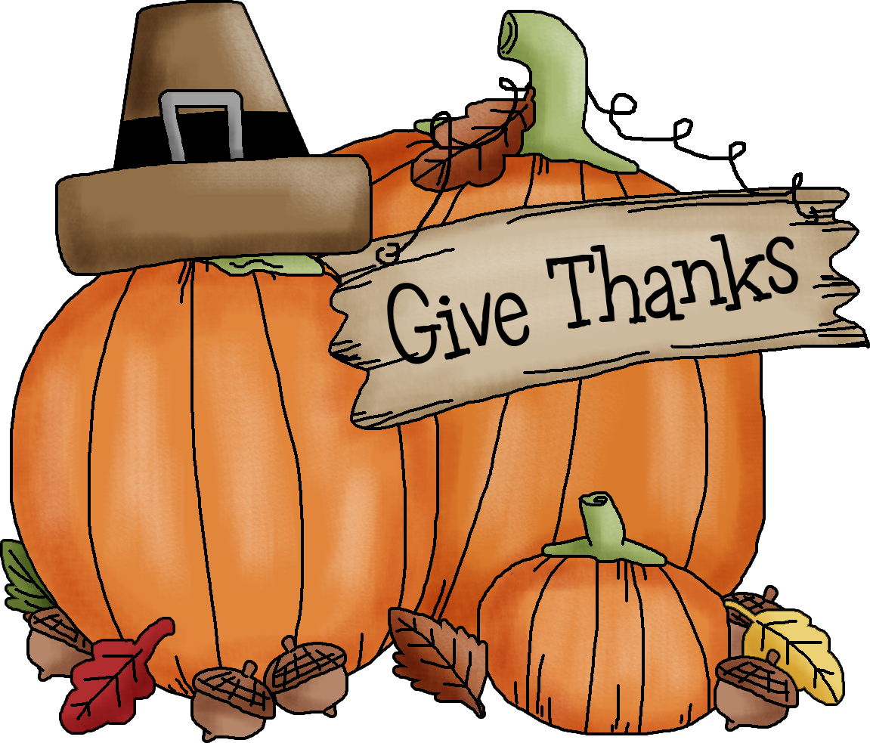 Tidings of
Just Older Youth (age 55+)
Harrisonburg 1st Church of the Nazarene

November 2018 Vol. 21 No. 7

 MYSTERY TRIP
Friday, October 26, 2018
Leave church at noon
Return approximately 3:30 p.m.
Cost: $1.00 transportation
Bonus surprise followed by buffet lunch at 1:30 p.m.
Sign up and pay by Wednesday, October 17th



 Fellowship Dinner 
2nd Wednesday, November 14th
5:30 p.m. Quad Room

 Nursing Home Outreach
Bridgewater Retirement Community
Thursday 2:00 – 3:00 p.m.
October 25th
November 29th December 13th

 J.O.Y. Directory Update

An updated J.O.Y. Directory is now available. If you would like a copy, please contact Sheryl by phone or text at 246-1303 or e-mail skwyse@comcast.net as the newsletter cannot be emailed according to church policy. Thank you!

 Praying for J.O.Y. Family & Friends

Prayer requests since September 12th. Thank you for being a prayer warrior and support system during a time of health concern, loss of loved one, recent surgery and/or rehab.

David Huyard health issues; hospitalization
Sam Pickenpaugh health journey/cancer
Pat Shoemaker infection/blockage/surgery, rehab
Lou Van Der Eems surgery for melanoma on hand

Passing of Loved Ones

Duane Cllick 10/9/18 sister of Juanelle Simmons
Amos Wimer 10/12/18 husband of Joan Wimer
Tami Wyse 11/7/17 daughter-in-law of Dwight & Sheryl
Shirley Hensley 11/9/17 sister of Gary (Bonnie) Thompson



Dear Pastor Jim & the J.O.Y. Group, Thank you for starting my 80th birthday off a little early with your special card, good singing, and the lovely Willow Tree, “Loving Angel” figurine. Love it! It is displayed next to Wayne’s Willow Tree figurine holding a heart and also my daughter-in-law’s gift of “Thinking of You” angel. Nice family set! So when you come to visit, just take a glance at the bookcase and there they are. What a special, caring group you all are. Blessings to you all,
Ann (Wayne) Lentz

November

1 – Don Shanholtzer 15 – Stacey Sinnett
2 – Carolyn Dean 15 – Violet Varner 92nd
6 – Marcia McGlamary 17 – Herb Bing
7 – David Purdy 18 – Carolyn Houff
10 – Betty Anderson 24 – Curtis Link
10 – Hal Corson 27 – Bill Troyer
14 – Vickie Waldrop 30 – Grace Pickenpaugh



HAPPY ANNIVERSARY

November 10, 1962 Dick & Pat Shoemaker 56th
November 24, 1979 Wayne & Carolyn Dean 39th
November 28, 1987 Frank & Vickie Waldrop 31st



Looking Ahead – 2018

December 1 Glorious Christmas Nights, Richmond
December 12 2nd Wednesday, Fellowship Dinner at 5:30

Next Newsletter items due by November 7, 2018

 The J.O.Y. Newsletter is
online at: http://abeaconofhope.org/joy/

Questions about the J.O.Y. Group? Contact Pastor Jim Harrison at jimanddebharrison@gmail.com or by phone at 540-607-0075
.

TURN CLOCKS BACK
Saturday Night, November 4th



 Glorious Christmas Nights 
“Angels & Kings”
Saturday, December 1st, 2018
West End Assembly of God, Richmond
Leave church 9:30 a.m. Return 6:00 p.m.
Cost $30 ticket & transportation
Lunch at Cracker Barrel before performance
Signup and pay by Sunday, September 30th
(Tickets ordered October 1st)

This year, Glorious Christmas Nights features a spectacular holiday musical called “Angels & Kings.” After arriving late to the daily briefing by the Archangel Michael, two zealous and good-hearted – if questionably competent – angels, Ted and Randall, are assigned the task of helping the Wise Men find the manger. In the zany twists and turns that ensue as they seek to locate the Wise Men, Ted and Randall take the opportunity to rescue two wayward youths and teach them what is important in life – taking them, ultimately, to the stable in Bethlehem for their divine appointment with Baby Jesus.

J.O.Y. GROUP RECOGNITIONS IN 2018

80th BIRTHDAYS
John Anderson, Loretta Blank, Thelma Harman,
Ann Lentz, Gail Link, Janet Messick and
Charlie Shifflett

50th ANNIVERSARIES
Neil & Jill Shepherd

 CHURCH EVENTS

IMPORTANT DATES in the life of Harrisonburg 1st Church of the Nazarene.

November 4-December 2 Christmas Gifts for local children
November 12-19 Shoebox Collection Week
November 23 – December Salvation Army Kettle ringers
December 9 Drummer Boy Fund offering



